PIERS ENTERPRISE

Page | 1

USER GUIDE
CONTENTS

PIERS ENTERPRISE

Getting Started............................................................................................................................................ 5
Logging In.............................................................................................................................................. 5
Home Screen....................................................................................................................................... …6

Building Your Query................................................................................................................................ 7-20

General Settings……......................................................................................................................... ………...7-9
Job Name……………......................................................................................................................... ………..7
Description…………….............................................................................................................................. 7
Date Range…………….............................................................................................................................. 7
Imports/Exports………............................................................................................................................. 8
Cargo Type……………............................................................................................................................... 8
Date……………..........................................................................................................................................8
Measurement……………...........................................................................................................................9

Geography…….........................................................................................................................................9-12
Ultimate Region………......................................................................................................................... …. 9
Ultimate Country ……......................................................................................................................... …10
Foreign Ultimate Port......................................................................................................................... .10
Foreign Initial Country….......................................................................................................................10
Foreign Initial Region…........................................................................................................................10
Foreign Initial Port….............................................................................................................................11
US Coast ……………................................................................................................................................11
US Port……………...................................................................................................................................12
US Origin/Destination…........................................................................................................................12
Output Column Selection.....................................................................................................................12

Cargo……......................................................................................................................... ………………………….13-15

Commodity Description .......................................................................................................................13
2 Digit HS Code…………….......................................................................................................................14
4 Digit HS Code ………......................................................................................................................... …14
6 Digit HS Code…………......................................................................................................................... 14
Cargo Type Filter…………….....................................................................................................................14
Output Column Selection ....................................................................................................................15

Carrier and NVOCC……............................................................................................................................ 16-17
Ship line……….......................................................................................................................................16
NVOCC Line ........................................................................................................................ …………………16
Output Column Selection ...................................................................................................................17

Shipper and Consignee ……....................................................................................................................17-18
US Territory……….................................................................................................................................17
US State ...............................................................................................................................................18 US Company……….................................................................................................................................18
Foreign Company ………........................................................................................................................18
Output Column Selection.....................................................................................................................18

Advanced Search ……..................................................................................................................................19
Company TEU Volume .........................................................................................................................19
Bill (BOL) Number ........................................................................................................................ ……….19

Estimate Report Size………..........................................................................................................................19

Submitting a Report ……......................................................................................................................... …...20

Query Status and History Page...................................................................................................................20-23

Status and History…………………………………………………………………………………………………………………………….20-21
Whose Query………….............................................................................................................................20
Starred Query…………….........................................................................................................................21
Date Range .........................................................................................................................................21
Job Name ............................................................................................................................................21
Description ..........................................................................................................................................21

Opening and Editing Your Report…………....................................................................................................22-23
Download Your Report........................................................................................................................22
Edit Your Report..................................................................................................................................23
Re-Run Your Report ……......................................................................................................................23
Edit Name and Description of Your Report........................................................................................23


Welcome to PIERS Enterprise!
The next generation of MyPIERS combines the ability to download data through an updated Data Query Tool (DQT) with a series of dynamic analytic dashboards. Our goal is to provide a single web portal where PIERS clients can access a set of tools that will provide insight into the data like never before! There are several new features that come along with the new tool.
New Features:
- Improved Speed – Leveraging new database technology, PIERS has exponentially improved the time it takes to run queries. In fact, through testing we have confirmed that searches are 92 percent faster.

- Ability to Download More Data – In the past, being able to download more than a quarter’s worth of data would be challenging and take a significant amount of time. Using the new Data Query Tool, you will be able to search for and download years of data in practically no time!

- Companywide Queries – Functionality exists for you to be able to create queries and then share them with your colleagues.

- Voyage Validated Only Option: Historically, PIERS has only provided data that has been “Voyage Validated” which means the Port, Carrier, and Sail Date were validated against U.S. Customs CF1401 logs. The main purpose behind this was so that every vessel call at a port has the same sail date. We have now added the option to view data even if it has not been voyage validated, so you can see the most recent data we have available in our system.

Web Browser Requirements:
- Optimally used with:
  - Chrome
  - Internet Explorer (IE) 11
- Compatible with:
  - Internet Explorer 9, and 10
  - Mozilla Firefox

Getting Started

Logging In
When you login to the application you will be prompted to enter your username and password. Enter www.www.mp2.piers.com in your internet explorer url bar.
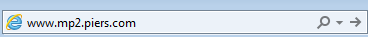

On the right hand side of the screen select Sign In


Enter your User name and Password and select Sign In
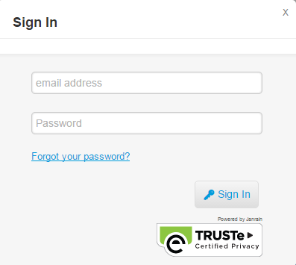

Home Screen

The application will automatically default to the ‘Home’ screen, buttons on the menu bar allow you to switch to either ‘Build Query’, ‘Query Status & History’, ‘Dashboards’,
or ‘Sign Out’.

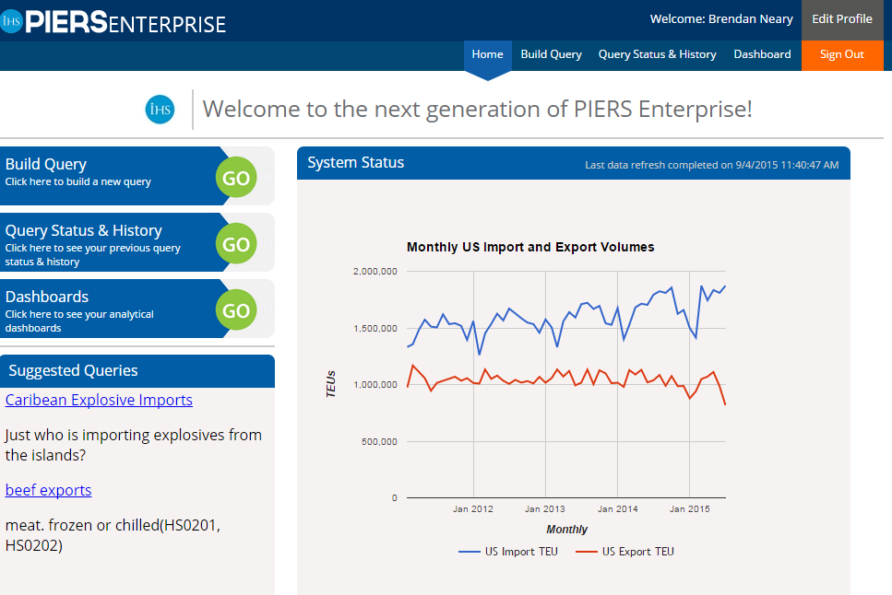

System Status

The Graph highlighted by PIERS will show customers the import and export volumes over time. The blue bar indicates the import volume and the orange bar indicates the export volume.
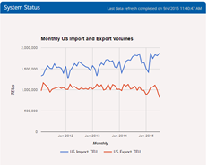

Building Your Query
The PIERS search function allows you to find information very easily and quickly across various filters.
This includes Geography, Cargo, Carrier & NVOCC, Shipper and Consignee. Continue to build query by selecting Build Query in the Menu Bar.

Start your query in the General Settings Area
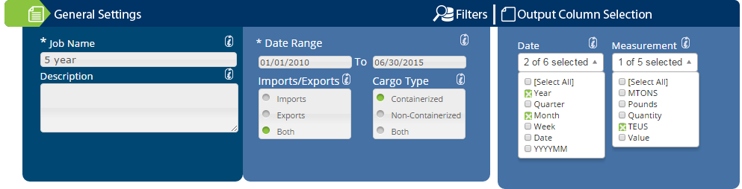

Job Name

To begin a search, always enter a job name into the designated location. This is mandatory for all searches and must exclude symbols and characters. This must be alpha and numeric.

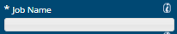

Description

PIERS now allows customers the ability to write a description of the search. This will be convenient when searching through past queries to fully understand what the report consists of based on your own words. Simply write into the Description text box
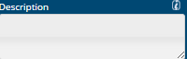

Date Range

Input a Date Range. The input boxes are FROM Date and TO Date, respectively. Note: The date range is inclusive and will default to the most recent completed month for both directions of trade.

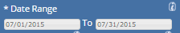

Imports/Exports

Choose (by clicking on) the direction of trade. Note: Both may be selected, but at least one must be selected. Also, the direction is United States centric.

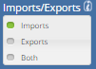

Cargo Type

Choose (by clicking on) the type of cargo to be included in the report. Note: Both may be selected, but at least one must be selected.
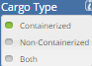

Date

Choose (by clicking on) time period fields to be included in the report. Note: More than one may be selected, however, it is highly recommended to only select those needed, as query performance improves with less selections. Dates can be output as you see fit. Select your desired output to be included in the report.
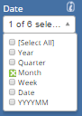

Measurement

Choose (by clicking on) time period fields to be included in the report. Note: More than one may be selected, however, it is highly recommended to only select those needed, as query performance improves with less selections. Measurements can be output as you see fit. Select your desired output to be included in the report.
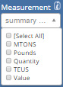
Continue your query in the Geography section by simply selecting the triangle next to the globe icon and Geography

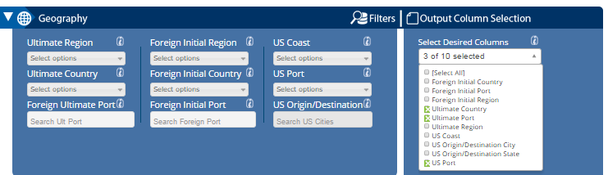

Ultimate Region

Choose (by checking) Ultimate Regions to be included in the report. Note: The Ultimate Region is defined based as the region in which cargo is ultimately destined (exports) or where cargo ultimately originates (imports). Enterprise customers may provide a definition for how this field is populated otherwise it defaults to PIERS defined values.
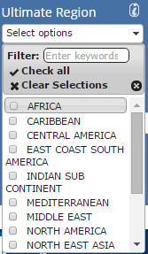

Ultimate Country
Choose (by checking) Ultimate Countries to be included in the report. Note: The Ultimate Country is defined based as the country in which cargo is ultimately destined (exports) or where cargo ultimately originates (imports).
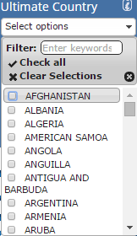

Foreign Ultimate Port

Choose (by checking) Ultimate Ports to be included in the report. Note: The Ultimate Port is defined based as the port (location) in which cargo is ultimately destined (exports) or where cargo ultimately originates (imports).
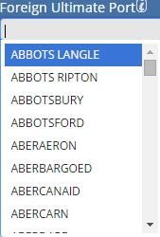

Foreign Initial Region

Choose (by checking) Foreign Initial Regions to be included in the report. Note: The Foreign Initial Region is defined based as the foreign (non-U.S.) region where cargo is loaded (imports) or where cargo is unloaded (exports). Enterprise customers may provide a definition for how this field is populated otherwise it defaults to PIERS defined values.
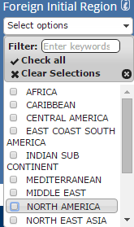
Foreign Initial Country

Choose (by checking) Foreign Initial Countries to be included in the report. Note: The Foreign Initial Country is defined based as the foreign (non-U.S.) country where cargo is loaded (imports) or where cargo is unloaded (exports).
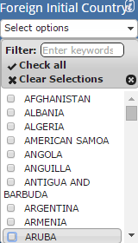

Foreign Initial Port

Choose (by checking) Foreign Initial Ports to be included in the report. Note: The Foreign Initial Port is defined based as the foreign (non-U.S.) port where cargo is loaded (imports) or where cargo is unloaded (exports).
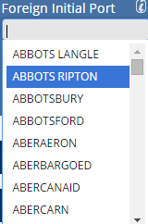

U.S. Coast

Choose (by checking) U.S. Coasts to be included in the report. Note: The U.S. Coast is defined based on USPORT. Enterprise customers may provide a definition for how this field is populated otherwise it defaults to PIERS defined values..
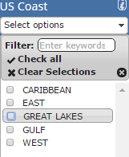

U.S. Ports

Choose (by checking) US Ports to be included in the report.

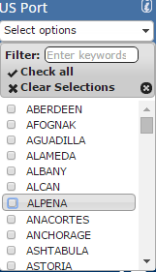

U.S. Origin/Destination

Choose (by typing into and clicking on) U.S. Origin / Destinations to filter the report by. The default is no filter. To remove a filter, use backspace within the input box. Note: U.S. Origin / Destination is the U.S. location that cargo originates from (exports) or is destined to (imports)

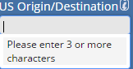

Output Column Selection

Choose (by clicking on) fields to be included in the report. Note: Many or All may be selected, however, it is highly recommended to only select those needed, as query performance improves with less selections.
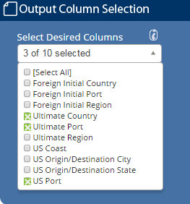

Continue your query in the Cargo section by simply selecting the triangle next to the grid icon and Cargo

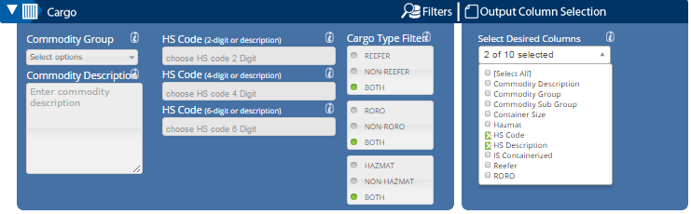

Commodity Group

Choose (by checking) Commodity Groups to be included in the report. Note: Enterprise customers may provide a definition for how this field is populated otherwise it defaults to PIERS defined values.
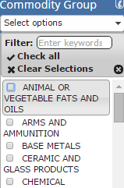
Commodity Description

Provide (by typing into) Key Word(s) in the Commodity Description to filter the report. The default is no filter. To remove the filter, remove the value in the input box.

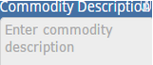

2 Digit HS Code

Choose (by typing into and clicking on) HS Chapters to filter the report by. The default is no filter. To remove a filter, use backspace within the input box. Note: HS Chapters are defined by the first two digits of the HSCODE.
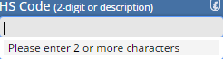

4 Digit HS Code

Choose (by typing into and clicking on) HS Families to filter the report by. The default is no filter. To remove a filter, use backspace within the input box. The HS Families available will be adjusted to any HS Chapter filters that have been applied. Note: HS Families are defined by the first four digits of the HSCODE.
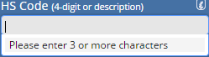

6 Digit HS Code

Choose (by typing into and clicking on) HSCODE to filter the report by. The default is no filter. To remove a filter, use backspace within the input box. The HSCODE’s available will be adjusted to any HS Chapter or HS Family filters that have been applied.

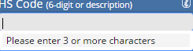

Cargo Type Filter

Choose (by clicking on) Cargo Type Filter. The default is to search for all cargo. To filter only refrigerated cargo, select the radial button next to REEFER. To filter only Non- Refrigerated cargo, select the radial button next to NON REEFER.

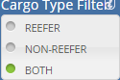

Choose (by clicking on) Cargo Type Filter . The default is to search for all cargo. To filter only Roll On Roll Off cargo, select the radial button next to RORO. To filter only Roll-On, Roll-Off cargo, select the radial button next to NON RORO.
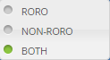

Choose (by clicking on) Cargo Type Filter . The default is to search for all cargo. To filter only Hazardous cargo, select the radial button next to HAZMAT. To filter only Non-Hazardous cargo, select the radial button next to NON HAZMAT.

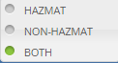

Output Column Selection

Choose (by clicking on) fields to be included in the report. Note: Many or All may be selected, however, it is highly recommended to only select those needed, as query performance improves with less selections.
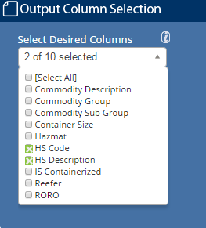

Continue your query in the Carrier & NVOCC section by simply selecting the triangle next to the anchor icon and Carrier & NVOCC.

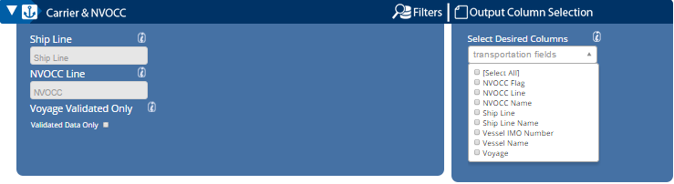

Ship line

Choose (by clicking on) Ship Line to be included in the report.
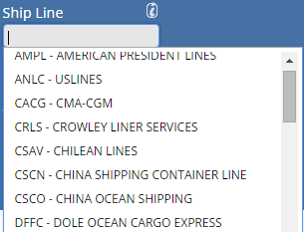
NVOCC Line

Choose (by clicking on) NVOCC Lines to be included in the report.

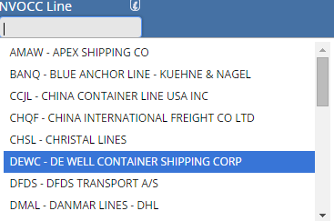

Output Column Selection

Choose (by clicking on) fields to be included in the report. Note: Many or All may be selected, however, it is highly recommended to only select those needed, as query performance improves with less selections.
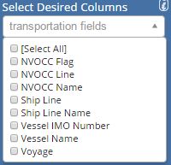

Continue your query in the Shipper & Consignee section by simply selecting the triangle next to the person icon and Carrier & NVOCC.

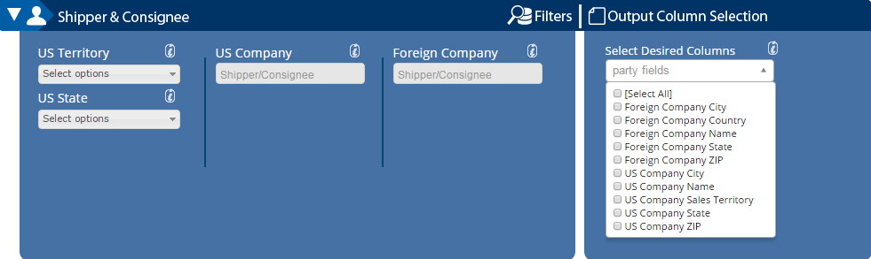

U.S. Territory Filter

Choose (by checking) U.S. Territories to be included in the report. U.S. Territories are determined by the first three values of the U.S. Company's ZIPCODE. Note: Enterprise customers may provide a definition for how this field is populated otherwise it defaults to PIERS defined values.
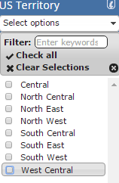

U.S. State Filter

Choose (by checking) U.S. States to be included in the report. U.S .States are determined by the state of the U.S .Company
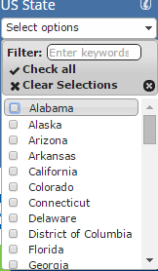

U.S. Company Filter

Choose (by typing into and clicking on) U.S. Companies to filter the report by. The default is no filter. To remove a filter, use backspace within the input box. Note: For imports, the U.S. Company is the Consignee. For exports, the U.S. Company is the Shipper.

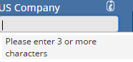
Foreign Company Filter

Choose (by typing into and clicking on) Foreign Companies to filter the report by. The default is no filter. To remove a filter, use backspace within the input box. Note: For imports, the Foreign Company is the Shipper. For exports, this field is not populated because of publication restriction.

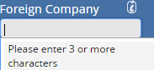
Output Column Selection

Choose (by clicking on) fields to be included in the report. Note: Many or All may be selected, however, it is highly recommended to only select those needed, as query performance improves with less selections.
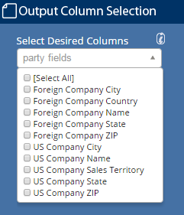
Continue your query in the Advanced Search section by simply selecting the triangle next to the person icon and Carrier & NVOCC.

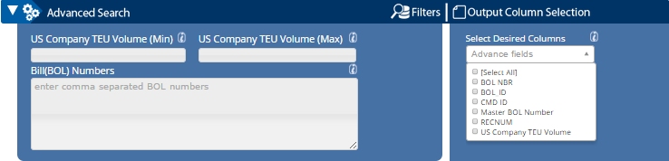

Company TEU Volume

Set thresholds for company shipments that you are interested in locating. Select TEU minimums and maximums to filter out large or small volumes that you are not interested in.

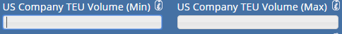

Bill (BOL) Numbers

Provide (by typing into) Bill Numbers to filter the report by. The default is no filter. To remove the filter, remove the value in the input box. More than one value may be specified by separating the BOL Numbers by a comma.
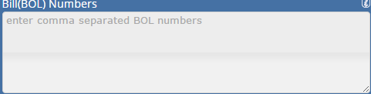

If you wish to get an idea of how many records are in your query size before you submit your reports for processing, simply select Estimate Report Size.

Once your query is built and you are ready to run the report, simply select the SUBMIT button and you will be brought to the Query Status and History page.

Query Status and History Page
Once your query is submitted you will be automatically directed to your Status & History Page to be able to download your report.

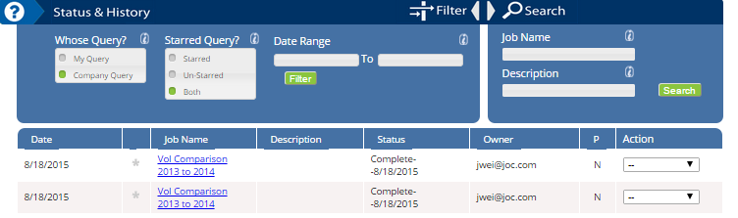

Whose Query

Users have access to all searches down within your company. You can choose to filter on all of the company searches or simply select the My Query button and hit search to filter to just view queries you have run.
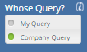

Starred Query?

Interested in marking a search as a favorite? Simply select the star icon next to the job name. We also allow the functionality to search for just your favorite searches by adding a filter for Starred or Un-starred searches.
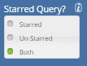

Date Range

Search for reports by timeframe of when you completed then. Input a Date Range. The input boxes are FROM Date and TO Date, respectively.
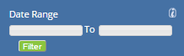

Job Name
Search for your queries by name, by simply typing in the name of the report that you ran into the search field.

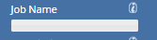

Description
Search for your queries by description, by simply typing in keywords from the description of the report that you ran into the search field.

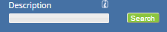

Opening and Editing Your Query

Downloading your report
Simply click on the Job name to download your report. Reports will automatically download into CSV and can be opened with Microsoft Access or Excel

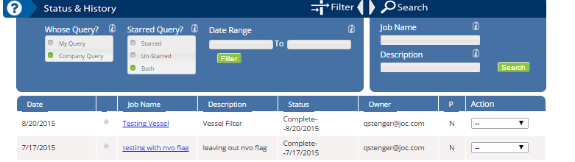

Re Run your report
Simply click on the Action drop down and select Run Query.

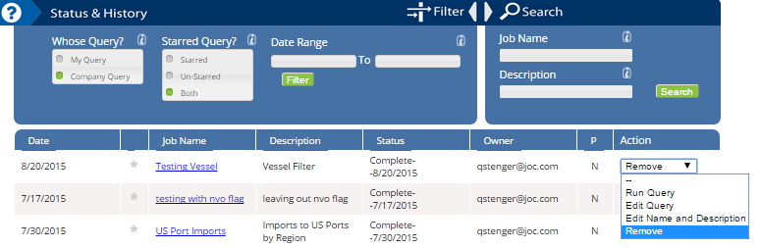

Edit your report
Simply click on the Action drop down and select Edit Query. This will return you to search screen where you can edit the fields of your search and resubmit.

Edit Name and Description of your report
Simply click on the Action drop down and select Edit Name and Description.

Reviewing PIERS Data Visualizations
The PIERS Enterprise Analytics allow you to visualize information very easily and quickly across various filters for quick and easy decision making
This includes Landing Page, Carrier Fact Sheet, Trade Lane Analysis, Sales Leads, Company Research. Continue to the PIERS Enterprise Analytics by selecting Build Query in the Menu Bar.

